# Culinary Delight System Installation

## Creating the OnlineOrderSystem SQL Server Database:

1. Start Microsoft SQL Server 2008 R2 🡪 SQL Server Management Studio.
2. Accept connections through Windows Authentication. Click **Connect.**

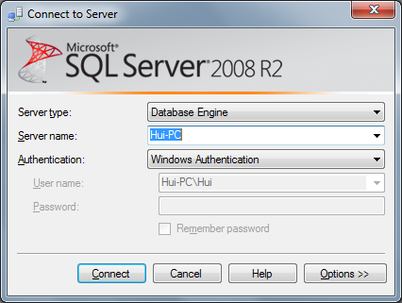

1. Right-click the root node in the Object Explorer window and select **Properties.** In the dialog that appears, select the Security page, and select **SQL Server and Windows Authentication mode:**

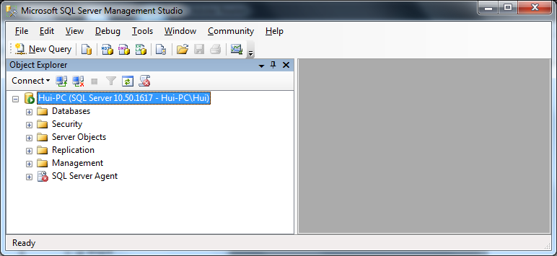

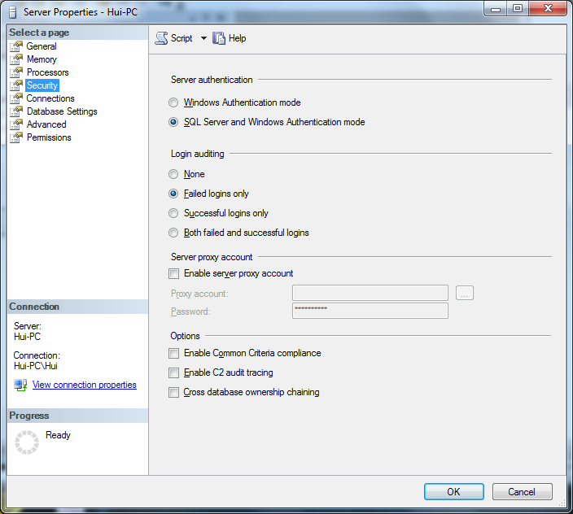

1. Click **OK** to save the change. You’ll be notified that you may need to restart SQL Server in order for the change to take effect. Accept Yes. Or you can do so by right-clicking the server node (the root node) in the Object Explorer pane and selecting Restart. In restart, connections through Windows Authentication.
2. Right-click the Databases node and choose **New Database....** Type **OnlineOrderSystem** for the name of the new database, and leave all the options as their defaults.
3. After clicking **OK**, the new database will be created.
4. Run the sql files in CD in the order of **SQLCreateProducts.sql**, **SQLCreateOrders.sql** and then **SQLAdminStoreProcedures.sql**.
5. Expand the **Security** ➤ **Logins** node in Object Explorer, right-click the **Logins** node, and select **New Login....**
6. In the dialog that shows up, select **SQL Server authentication**, and type **onlineordersystem** for the username and **password** for the password. **Unselect** the **Enforce password policy** check box. This will make the way easier. Change the default database to **OnlineOrderSystem**. Change default language to **English**.

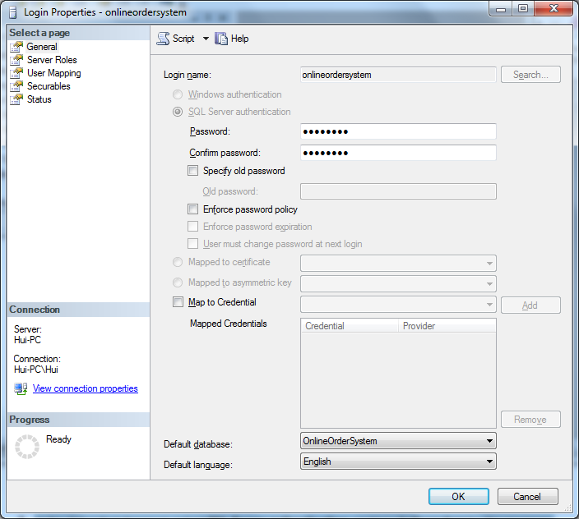

1. Select **User Mapping** from the Select a page pane, check the **OnlineOrderSystem** table from the list, and check the **db_owner** role:

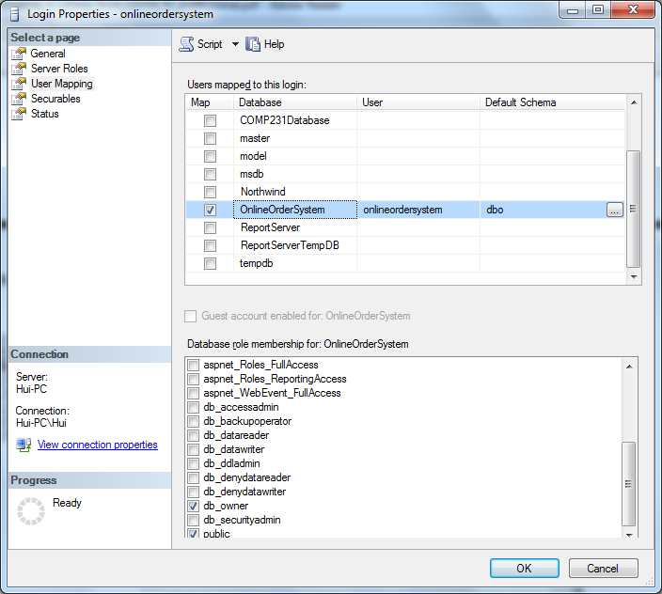

1. Click **OK**, and wait for your user to be created.
2. Close SQL Server Management Studio. Restart the SQL Server Management Studio again and login with the **onlineordersystem** login name and **password** password in SQL Server Authentication:

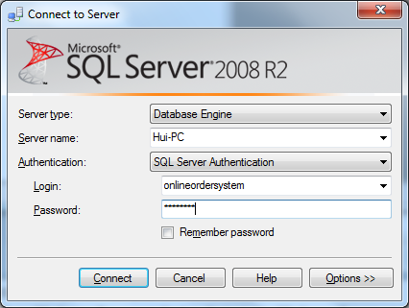

1. Make sure this login name and password can login to the server. It should login successfully. Then close the SQL Server Management Studio.
2. Open cmd in your window. Execute the following command from **C:\Windows\Microsoft.NET\Framework\v2.0.nnnnn\** with the following parameters.

C:\Windows\Microsoft.NET\Framework\v2.0.50727>aspnet_regsql –U onlineordersystem -P password -S (local) -A all -d OnlineOrderSystem

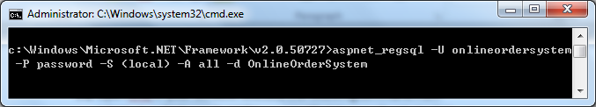

**The output should resemble this:**

C:\Windows\Microsoft.NET\Framework\v2.0.50727>aspnet_regsql –U onlineordersystem

-P password -S (local) -A all -d OnlineOrderSystem

Start adding the following features:

Membership

Profile

RoleManager

Personalization

SqlWebEventProvider

.......

Finished.

1. At the end you should see the word of “Finished”. This means the tables in the database are created successfully. Close cmd window.
2. Copy the folder **CulinaryDelight** from the CD to your computer. Open Visual Studio 2012. File 🡪 Open 🡪 Project/Solution

In the Open Project window, navigate to the folder CulinaryDelight, and select **CulinaryDelight.sln** under this folder. Click **Open**.

1. After the project opened, from the menu click PROJECT 🡪 ASP.NET Configuration
2. Click the Securitytab. You should get a screen like the one shown in following:



1. Click Enable **roles**.
2. Click Create **or Manage roles** and create a new role named **Administrators** and a new role named **Customers**. Click **Back**.

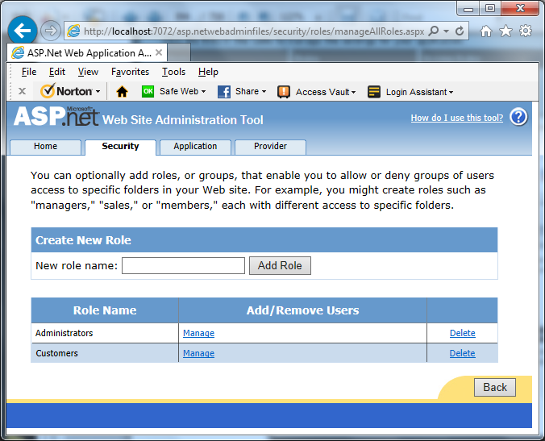

1. Click **Select authentication type** and select the **From the Internet** option. Click **Done**

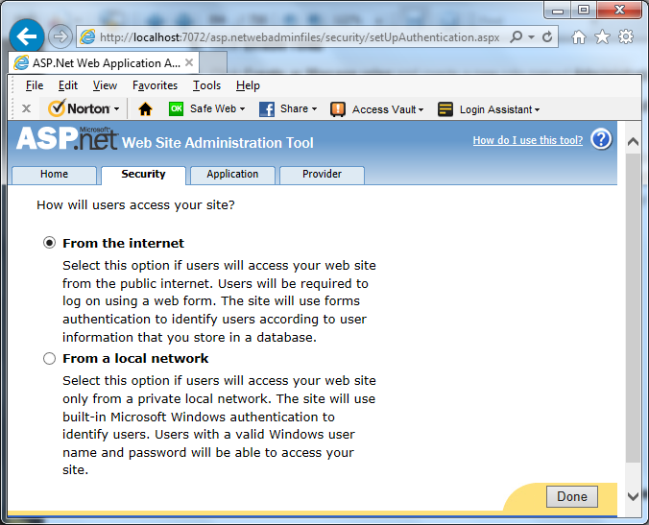

1. Click **Create user** and add a new user named **admin** with the password **!123456.** Add some text of your choice for E-mail, Security Question, and Security Answer. Assign the user to the **Administrators** role by checking the check box, and click **Create User.**

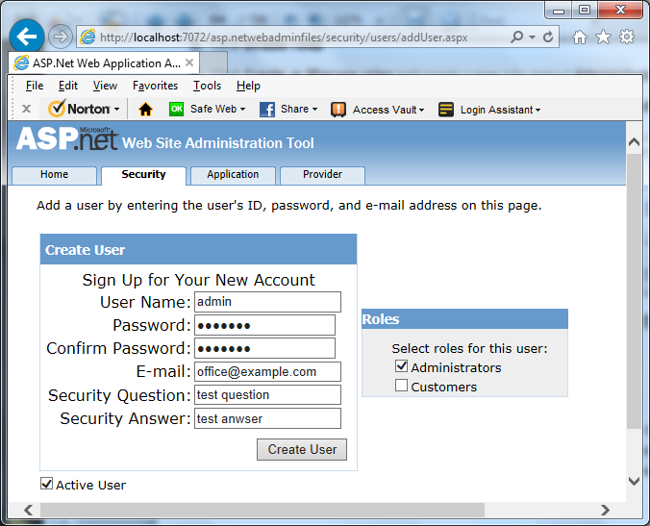

1. Click **Back** to get to the main Security page. Make sure that you have two role and one user, and then close the window.
2. Switch back to Visual Studio. You’ll probably be asked to reload web.config, which was modified by an external program. Select **Yes**.
3. Use **Google Chrome** to run the application because one of our web pages embeds a google map which Google Chrome will support but not Internet Explorer. Now you can play around the application!